**Transient analysis of First RC Circuit**

**OBJECTIVES:**

* + - * RC Circuit
      * Pspice
      * RC Circuit using PSPICE

**RC Circuit:**

An RC circuit is a circuit with both a resistor (R) and a capacitor (C). RC circuits are freqent element in electronic devices

The combination of a pure resistance R in ohms and pure capacitance C in Farads is called RC circuit. The capacitor store energy and the resistor connect in series with the capacitor control the charging and discharging of a capacitor.

**Example** The RC circuit is used in camera flashes, pacemaker, timing circuit etc.

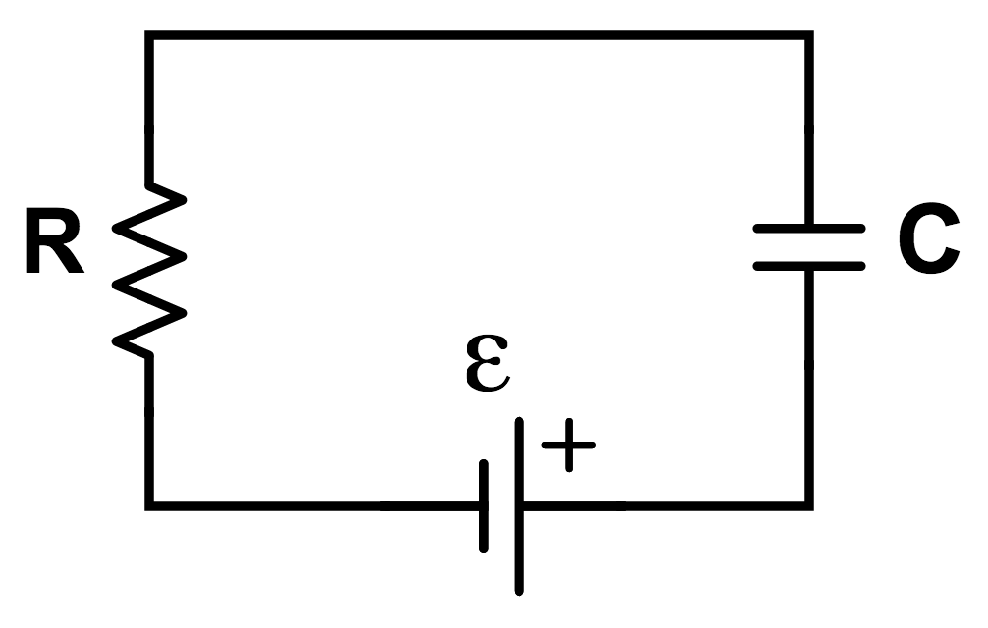

CIRUIT DIAGRAM

**pspice:-**

The circuit file contains different functions which makes the work of an engineer more easy. One can put any sort of symbol using this software and can make different types of circuit diagrams.

**RC Circuit using PSPICE:**

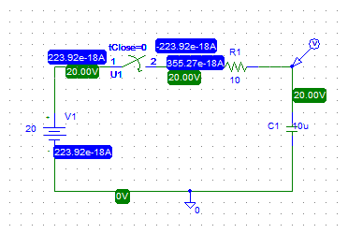

**STEPS:**

* For capacitor use **“C”**
* For switch we use **“sw-tclose”**
* y.PNGfor voltage maker
* Select **“analysis”** from menu bar
* In analysis select **“setup”.**
* In setup.check **“transient”**button.
* Click **transient** button
* Pop window will appear
* Check skip initial transient solution and then click **“ok”**
* Then, simulate graph will appear
* In graph window, there is trace button
* Click on **“Add trace”**
* Click on **I(Ci)**

**GRAPH:**

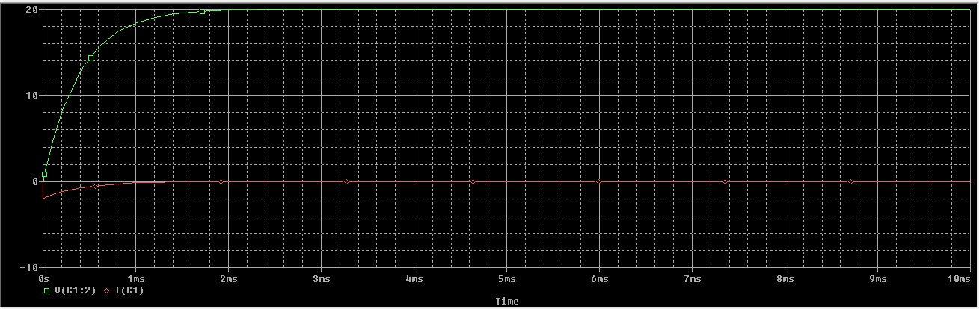

**CONCLUSION**

Like the other network **analysis** procedures, we can use to find out the RC through a particular element or elements using pspice.